Content Table

1. Executive Summary 2

2. Revision Table 3

3. Introduction 3

4. Contents 3

4.1 Planning Chapter 3

4.2 Progress Chapter 3

5. Conclusions 6

6. Bibliography 6

**1. Executive Summary**

*This report documents the current status of the project, including planning and progress.*

*It describes:*

* *The tasks performed and their relevance within the project.*
* *The resources used throughout development.*
* *Performance metrics to assess efficiency.*
* *A comparison between the planned execution and the actual progress.*

*Additionally, it presents a cost estimation and an analysis of potential areas for improvement in future phases.*

**2. Revision Table**

| Revision number | Date | Description |
| --- | --- | --- |
| 1 | 02/03/2025 | The report was created |
|  |  |  |

**3. Introduction**

*This document presents the Planning and Progress Report for the project, specifically prepared for Student 5.*

*It provides a comprehensive record of the project's planning and development, detailing:*

* *Tasks completed and their role within the project.*
* *The responsible individuals for each task.*
* *A comparison between estimated and actual time spent on each task.*

*Additionally, the report:*

* *Outlines methodologies used for task management, ensuring adherence to best practices.*
* *Highlights challenges encountered during development and the solutions applied.*
* *Provides an initial cost estimation, followed by an analysis of estimated vs. actual costs.*
* *Includes performance indicators to assess efficiency and goal completion.*

*This report serves as a foundation for evaluating the project’s progression and identifying areas for improvement.*

**4. Contents**

**4.1** **Planning Chapter**Task List

| Task | Description | Responsible person | Planned time | Real time |
| --- | --- | --- | --- | --- |
| 3 | Aircraft Maintenance Technicians Data Requirements | David Escudero Aldana | 40 minutes | 57 minutes |
| 4 | Aircraft Maintenance Records | David Escudero Aldana | 40 minutes | 38 minutes |
| 5 | Maintenance Tasks | David Escudero Aldana | 40 minutes | 30 minutes |
| 6 | Sample Data for Testing | David Escudero Aldana | 40 minutes | 85 minutes |
| 7 | GitHub Planning Dashboard | David Escudero Aldana | 5 minutes | 7 minutes |
| 15 | Technician Dashboard Indicators | David Escudero Aldana | 90 minutes | 23 minutes |
| 16 | UML Domain Model | David Escudero Aldana | 45 minutes | 32 minutes |
| 26 | Technician Course Notice Board | David Escudero Aldana | 120 minutes | Pending |
| 27 | Analysis report | David Escudero Aldana | 20 minutes | 15 minutes |
| 28 | Planning and progress report. | David Escudero Aldana | 20 minutes | 21 minutes |

Screenshots of the different pages of progress

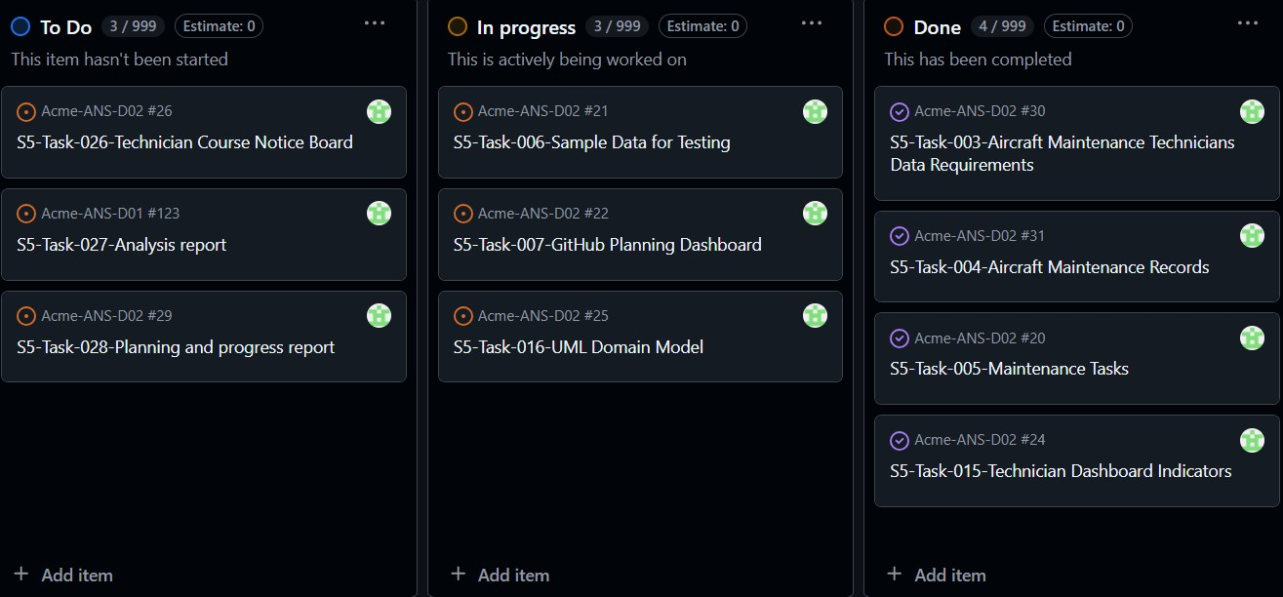

In the three columns we can see tasks that are already completed, others in progress, and some still pending.

Budget Estimation

| Role | Estimated hours | Hourly cost | Total cost |
| --- | --- | --- | --- |
| Analist | 1 hour | 30,00€ | 30,00€ |

**4.2** **Progress Chapter**  
Challenges and Resolutions

| Problem | Description | Solution |
| --- | --- | --- |
| Intentionally blank |  |  |

Cost Comparison

| Role | Estimated hours | Real hours | Hourly cost | Real cost |
| --- | --- | --- | --- | --- |
| Analist | 1 hour | 1 hour | 30,00€ | 30,00€ |

**5. Conclusions**

In conclusion, I can say that since this was the first deliverable and primarily consisted of documentation tasks, there is not much to draw conclusions from. The work was mostly focused on setting up the initial structure and ensuring all basic requirements were met, which leaves little room for deeper insights or conclusions at this stage.

**6. Bibliography**

Does not apply